Group No. | Group Members (Regd. No.) | Project Title
1 | Dinanath Dash (2241004161) | Building A Line Following Robot Using Arduino
1 | Himanshu Sekhar Dash (2241004163) | Building A Line Following Robot Using Arduino
1 | Priyansu Nayak (2241014108) | Building A Line Following Robot Using Arduino
1 | Ashutosh Raj (2241018015) | Building A Line Following Robot Using Arduino
1 | Swarnabha Roy (2241018192) | Building A Line Following Robot Using Arduino
1 | Subhojeet Sarkar (2241019321) | Building A Line Following Robot Using Arduino

- Introduction:
A line-following robot is an autonomous mobile machine capable of detecting and following a predetermined path, typically represented by a black or white line on the surface. These robots are widely used in automation, logistics, manufacturing, and research for demonstrating the fundamentals of robotics, sensor integration, and embedded control systems.
In the industry, line-following principles are foundational in automated guided vehicles (AGVs) used in factories and warehouses to transport materials along specific paths. Such robots help reduce human error, increase efficiency, and enhance precision in controlled environments.
The concept dates back to early robotics research in the 1970s and 1980s when simple analog circuits controlled light sensors. With the advancement of micro-controllers like Arduino, these systems have evolved into smarter and more flexible solutions that can adapt to path variations, detect intersections, and even make decisions autonomously.
The need for this study arises from the growing demand for low-cost automation and hands-on learning in robotics and embedded systems. Building a line-following robot provides practical exposure to real-world control systems, sensor-based navigation, and algorithmic decision-making.
- Problem identification and Problem Formulation:

Problem Identification:
Modern industries increasingly rely on autonomous systems to perform repetitive tasks. However:
- Manual material movement leads to inefficiencies and errors.
- Full-scale autonomous robots are expensive and complex.
- Students and beginners often lack practical understanding of embedded control and sensor interfacing.

Problem Formulation:
Design and implement a low-cost, Arduino-based autonomous robot capable of detecting and following a line using IR sensors, controlling motor speed and direction through a motor driver, and maintaining stability and accuracy on curved or uneven tracks.

Brief Solutions:
- Use IR sensor modules to detect line contrast (black/white surface).
- Process sensor data using Arduino UNO for decision-making.
- Drive motors through L298N/L293D motor driver based on sensor feedback.
- Calibrate sensor sensitivity for various lighting and surface conditions.
- Optimize line-following logic for smooth turns and obstacle avoidance (optional extension).
- Objective of the Project:

Broad Objectives:
- To design and develop an Arduino-based line-following robot capable of autonomous navigation.
- To integrate sensor data processing with real-time control of motor movement.
- To explore embedded systems, robotics, and automation principles in a practical scenario.

Specific Objectives:
- Interface IR sensors with Arduino to detect black and white surfaces.
- Implement a decision algorithm to follow the path based on sensor readings.
- Use a motor driver (L293D or L298N) for controlling DC motors.
- Tune the robot for smooth and stable line tracking, even on curves.
- Analyze robot performance across different line patterns and lighting conditions.
- Block Diagram of the Project:

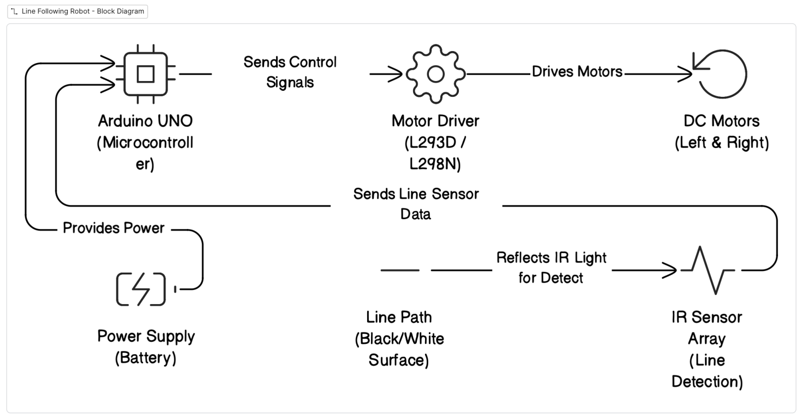
Fig. 1: Block Diagram of the Line Following Robot

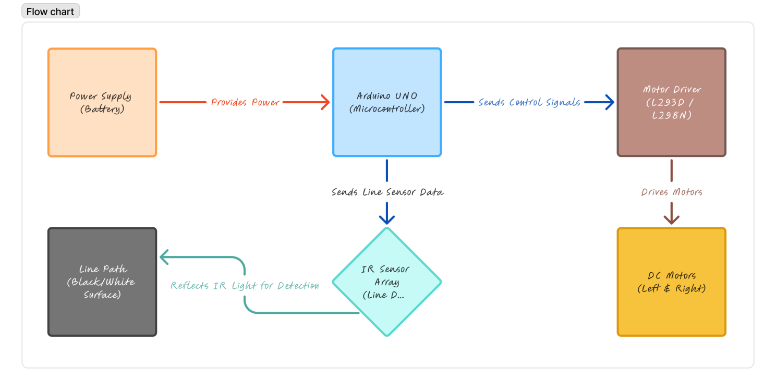
Fig. 2: Flow Chart of the Line Following Robot

- Circuit Diagram of the project:
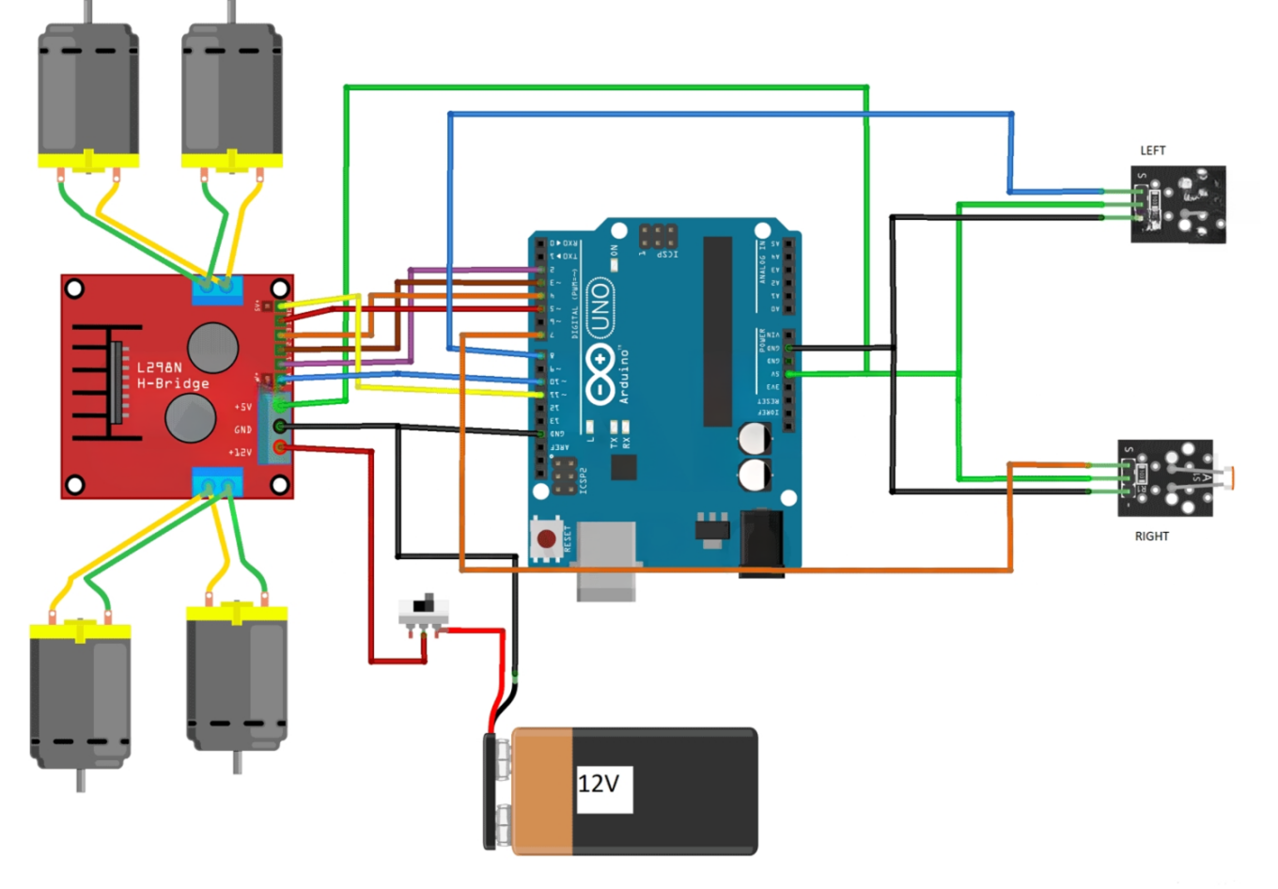
9V
Fig. 3: Circuit Diagram of the Line Following Robot

- Components/Items Required:
Sl. No. | Name of the Components | Specification | Quantity
1 | Arduino UNO | ATmega328P, 16 MHz | 1
2 | L298N Motor Driver Board | Dual H-Bridge motor driver | 1
3 | Infrared Sensors | Digital IR reflective sensor | 2
4 | BO Geared Motor with 65mm wheels | 100 RPM, 12V DC | 2
5 | Castor Wheel | Universal ball-type wheel for front support | 1
6 | AA batteries with Battery Holder | 1.5V AA cells (x6) | 1
7 | ON-OFF Switch | SPST toggle | 1
8 | Jumper Wires | 20 cm (male - female) | As much as required
9 | 3D Printed Chassis | -------- | 1
10 | Black PVC Self-Adhesive Tape | -------- | 1

Full Signature of Group Members:
1.
2.
3.
4.
5.

6.
Signature of Corresponding Faculty

